Everglades National park
Bio – Skip Snow
July 2011

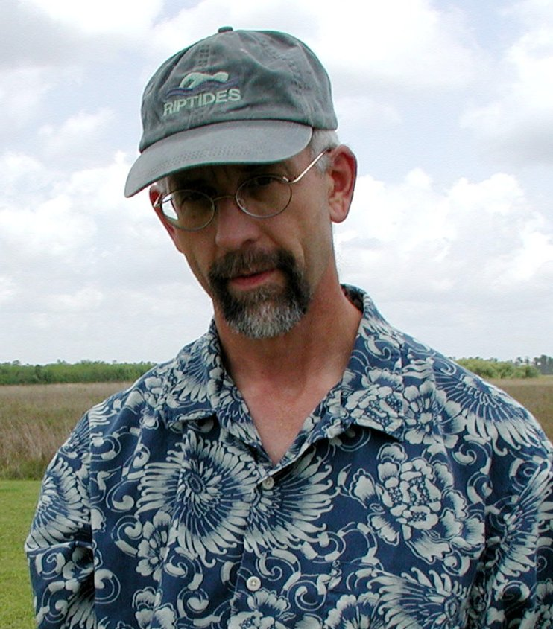
Ray W. “Skip” Snow has been with the National Park Service for 36 years, 23 of which he has worked at addressing natural resource management issues at Everglades National Park. Snow has a M.E.S., Master of Environmental Science from Miami University (1977), Oxford, Ohio, and a B.A. in Zoology also from Miami University (1973). Since his arrival at Everglades National Park in 1988, Snow’s experience in South Florida has involved a broad range of natural resource issues including evaluating effects of recreational use and water management scenarios on wildlife resources. A major focus of Snow’s recent work has focused on the management and control of non-native invasive animal species and the reintroduction of native extirpated species. Current projects include control strategies for non-native Burmese pythons and reintroduction plans for native eastern bluebirds, brown-headed nuthatches, and Florida wild turkeys.

