
Society of Environmental Journalists
P.O. Box 2492
Jenkintown PA 19046 USA
Phone: (215) 884-8174 • Fax: (215) 884-8175
sej@sej.org • www.sej.org

Board of Directors

President: Christy George
Oregon Public Broadcasting

Vice President, Program Committee Chair: Carolyn Whetzel
BNA

Vice President, Membership
Committee Chair: Peter Fairley
Independent Journalist

Treasurer: Don Hopey
Pittsburgh Post-Gazette

Secretary: Peter Thomson
BBC’s The World

James Bruggers
The (Louisville) Courier-Journal

Jeff Burnside
WTVJ NBC 6 Miami

Rob Davis
Voice of San Diego

Douglas Fischer
DailyClimate.org

Cheryl Hogue
Chemical & Engineering News

Robert McClure
InvestigateWest

Tim Wheeler
The Baltimore Sun

Sharon Oosthoek
Independent Journalist

Representative for Academic
Membership: William Kovarik
Radford University

Representative for Associate
Membership: Heather King
Independent Journalist

Founding President
Jim Detjen
Michigan State University

SEJournal Editor
Mike Mansur

Executive Director
Beth Parke

March 15, 2010

The Honorable Patrick Leahy, Chairman
The Honorable John Cornyn
Judiciary Committee
224 Senate Office Building
United States Senate
Washington, DC 20510

Dear Senators Leahy and Cornyn:

The Society of Environmental Journalists hopes that you will continue in this Congress your efforts to pass the Faster FOIA Act, creating an advisory commission to address the substantial delays in processing Freedom of Information requests to federal agencies.

For environmental journalists, who attempt to report what the government knows and what it is doing in the aftermath of disaster, time is clearly of the essence. Terrible and poignant examples of Freedom of Information gone wrong exist. Journalists were quick to file FOIA requests following the tragic displacement of New Orleans citizenry by Hurricane Katrina in 2005. Some agencies simply did not release information they had in hand about potential dangers to health and safety. There was immediate and compelling need for that information and some of it has not been released to this day.

Government agencies identify threats to health and safety. They study the vulnerabilities of dams, pipelines, coal mines, and other structures. They collect data on the effects of manufacturing on soil air and water. They monitor seismic faults, atmospheric changes, and the well-being of waterways.

Environmental journalists may need to report matters quickly even absent immediate threat to health and safety. When the government contemplates passage of laws or regulations the public needs government information if it can participate in those decisions.

For environmental journalists, the most serious impediment to Freedom of Information is delay. We would applaud the commission for studying what causes delay and implementing the findings of such a study would be very welcome to us.

We are grateful for your continued enthusiasm for making Freedom of Information work.

Sincerely,

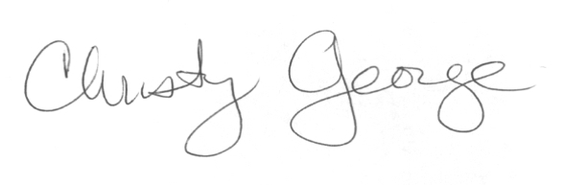
Christy George, SEJ President
Phone: (503) 293-4001

